Pedro | This was an interesting book—it takes the blurring of boundaries like biological/social and human/non-human and dramatizes them in the extreme way that only science fiction can. The blurry line between consent and violation in this text was particularly disturbing. It might be interesting to explore the strange relations between the Oankali in terms of the affects of colonialism (and, perhaps, slavery).  There is a strange attraction that the Oankali have for humans. In part, it is about our not so appreciated “talents,” like the tendency to grow malignant tumors, but there is also a sense of an “excess” of life that is sometimes associated with (often “illicit”) desire for the colonial/racialized other. On the other hand, there is a kind of civilizing mission—to cure what they diagnosed as the terminal incompatibility of our innate hierarchical drive and our intelligence—along with a strong paternalism. There is also the (unequal, semi-) incorporation of humans into Oankali homes (often as caregivers for the young), accompanied by the dangers not only of rebellion, but also of forming personal affective ties that subvert or at least sit uneasily with the “proper” relations of power and discipline (seen, for example, in the disagreements between Nikanj and Kahguyaht over “surprising” Lilith). On the human side, there is the danger of not only co-optation, but also the larger, looming one that Oankali captivity will transform them into something alien. While no character has yet embraced this change, perhaps something akin to anti-colonial nationalist movements, adopting and co-opting the Oankali notion of progress, will emerge later in the series. Finally, despite the affective ties (and the crazy mind melding interspecies sexy time), there is still a limit to the understanding (both ways) that cannot be overcome, despite the Oankali insistence that they know their humans better than they know themselves.
db | I would really like to talk about the withholding of information and technology. The implicit technological determinism in this sort of thinking (its all over sci-fi, from the Oankali to the Federation’s Prime Directive to something I dimly remember from Avatar) implies that gaining access to technology is not just a means to an end, but can fundamentally alter entire societies. The weird (confusing? disturbing?) thing here is that I don’t disagree with its role as a plot device. Which is to say, I agree that if you give the humans guns they’re going to shoot each other and their captors. Or, a less obvious example, if you give them modern tools when they return to earth, you might give obvious advantages to some and not others, thus establishing the beginnings of an unequal society. What does this mean for our (STS’s) ideas/theories of material agency and technological determinism?  Also, I was looking around for fan renderings of the Oankali and I ended up finding this instead. I’d rather have the support of other people having similar haunting dreams than to have to deal with this alone:  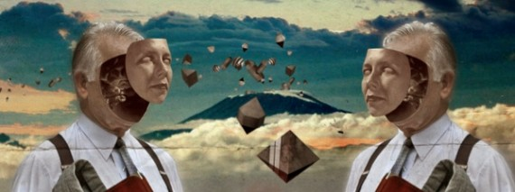  I think this is the closest I could find to what was described in the text:  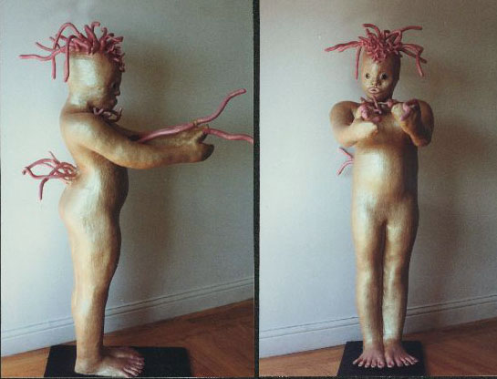
Michael | I very much enjoyed Dawn for a number of reason, primarily due to my negotiated reading the text’s challenges to traditional gender roles. However, I also found an underlying theme of genetic determinism as something that was not challenged, but reinforced. This is most apparent, for me, with how Oankali’s position on hierarchy as genetically specific to humans was performed on the island, ultimately ending in destruction (like what happened to earth).  Yet, the text did leave room (specific narrative and textual gaps - closer examination is required) to play with gender roles. Since gender has been a major topic of fan fiction writing and I have an affinity for studying fandom, I thought I would see if there was any Xenogenesis/Lilith Brood Series fanfic. I found one on fanfiction.net and two on Archive of our Own (there was addititional fanfics from Butler’s other work, which I will touch on in a bit). While gender can be analyzed in each, “Heterosis” by ambyr on Archive of our Own http://archiveofourown.org/works/276600 (Unlike fanfiction.net, this fan ran website with direct links to OTW) was particuarlly relevent. The fic takes place after the second book in the series has ended, and follows Akin, a construct (human-Oankali mix I am guessing), who had physically matured but has not mated. Akin struggles to come to terms with the social pressures of mating with an ooloi, male, and female. In working through ambyr writes,  He stretched his tentacles toward her to better read her mood. "Not when it affects your work. Lilith says you've been unsettling the colonists."  "Lilith says?" She shook her head. "Akin, it's a human thing. I don't think you'd understand."  "I understand humans," he said, affronted.  "No. You understand constructs. You extrapolate to humans. And most of the time you're right." She sighed. "Why do you and Dehkiaht want a mate?"  "Want isn't the right word." He had been neglecting Dehkiaht, too. He and the ooloi lay together at night, and he had passed on all the samples he and Yori had gathered in their journey, but that was all. They could not complete the connections they needed to make alone, could not build children. "To be oankali is to be three. Male, female, ooloi. We are incomplete."  "Biological determinism," she said with a grimace. He waited, patient. She knew that to him the phrase was almost meaningless, a tautology. "There were humans who thought the same way about humans, before the war. That a man needed a woman, a woman needed a man. That to be otherwise was to be unbalanced. They were wrong, of course. I wonder what they make of you lot." She laughed. "Not quite what they dreamed. You do see where I'm going with this?"  "Yes," Akin said slowly. "Before my metamorphosis, I used to sleep with human women. But sometimes the men would approach me, too."  "Did you say yes?" Her curiosity was dry, a scientist's.  "Yes." The memories were awkward. He had not understood, the first time, what was being asked. It was not an oankali thing, not something the humans in Lo spoke of. "Twice."  "I'm surprised you did that much." Yori sighed, and set the spoon aside. "Oankali don't--but you would know better than I."  In the end Akin and Dehkiaht mate with Tiikuchahk (another male construct).  Commenters on the fan fic note how the fic is consistent with canon, while pushing gender roles past Butlers underlying assumptions. sqbr writes  It both extrapolates from canon very smoothly, exploring the same ideas of identity etc, but also questions the assumptions Butler made about gender and sexuality. And you tell a nice little self contained story as well. Brilliantly done!  I think that this is a good example of how fans develope minor characters (this is an assumption that Akin is a minor character) and flex the textual boundaries that the author sets. Fans are able to balance both textual pleasure and critique with fan fiction. It may be argued that the assumptions and determinisms that Bulter makes about gender are not as consistent within popular discourse as they once were, if this is so than the text provides resources and a jumping point for working through present day issues. The fan, in a sense, updates the texts to fit our times.  Generic cycles - 1980s Westerns are not in production, but Science-Fiction is on a rise. I think that we could structurally compare this book to the western filmic structure.  Two more fannish things. It seems that the Lilith Brood series does invoke fan labor across media. First, check out this awesome feminist fan vid by Chaila, which is a trailer to Butler’s book Parables. It uses fiction and non-fiction audiovisual sources to construct text that extends the boundaries of the narrative into new media and comments on present day politics. Again a process of updated the text to make sense of present day issues. Alexi Lothian from the site Antenna does a great piece on Chaila’s vid: http://blog.commarts.wisc.edu/2012/06/19/adaptation-by-remix-vidding-feminist-science-fiction/  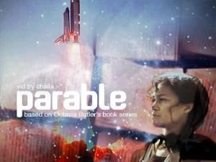  Second, here is a great piece of fanart by Krista Franklin & D. Denenge Akpem called Octavia, Dear (2008). I think it is a tribute piece to her after death.  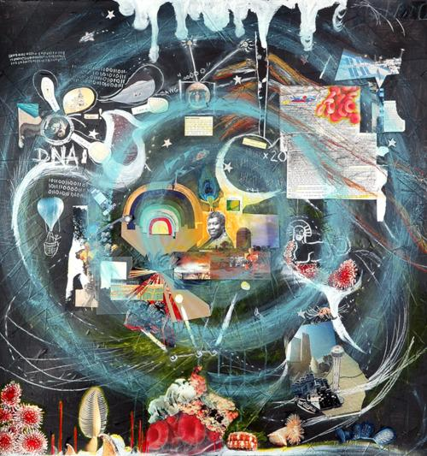
Dan | So, let me lead off by pointing out that there is something somewhat unnerving about the Oankali's nonchalant colonialist impulses are sort of unnerving. They operate with what they perceive to be the human's best interests in mind (the language of, 'we'll tell you when we think you're ready' echoes throughout the Womb and Family) and while not always immediately lethal, demonstrate no problem exercising force somewhat unilaterally against the humans. It's a benevolent oligarchy, but it's an oligarchy of technocrats nonetheless.  That being said , what they do suggest is a kind of approach that is somewhat different than the typical space invaders kidnapping people and promising utopia. Rather, they don't immediately say that the humans are now going to live on the ship and deal with Oankali as members in the space menagerie they keep- They're going to go back onto earth to repopulate the planet and start new. But with bows and arrows? My problem is that while I buy that certain technologies enable people to do significant amounts of damage to themselves and others (Look at Curt with a simple ax) it ignores the fact that technologies are embedded in a complex network of techniques and other systems to make them work and thus, it’s not as simple as removing technological systems will solve all the problems of society. Why not build a more advanced settlement and work their way out from there? Obliterate all human knowledge up until that point and return everyone to gather-hunter state as if that is where human society is most pure and unburdened of problems? While I enjoy the comment on social structure, I think it is most right on when it suggest that in this scenario, human beings are more likely to fall back into ways of relating to each other that they recognize and have practice with and that the technology at hand plays a dialectical role. Curt kills because that's what Curt is about- having an axe or a bomb or a laser rifle only changes the barrier it take for him to enact that script.  I guess I end by pointing out that the way in which, gender and humanity are constructed in this are… I dunno. Very 1980's. Lilith's power isn't derived from the fact that she has, in a sort Tank Girl move, transcended both genders into a third combination (You know, ooloi style) but seems to rest in the same binary between tough masculinity and emotional femininity that isn't as radical as it comes across. I think of Sherrie Inness' book Action Chicks: New Images of Tough Women in Popular Culture where she points out that this is a pretty common trope in the creation of action women. Sure, they invert the gender of the protagonist, but they still rely on the gender binary gender system to make sense of the world.    As for pictures of humanity- Yeah. It's the 1980's. Nuclear war is imminent. Our proudest moments- not nuking each other off the face of the planet, won't come for some time (to what extent we've fully put that behind is another question) but there is a very strong notion that humanity IS one thing and Lilith stands outside not merely because she has a chemical change to her body, but because she can reflect on this problem and choose to be another way. It would seem that the more STS way of framing this story is that Lilith is NOT different from the other humans, but her agency to act as a broker between various kinds of leadership and use of technology gives her the ability to break out of the rather limited position the other humans are left with. Curt, for all his bluster, has more pity from me than scorn because what else can he do but inact the same force politics he was used to? He is not provided with interpersonal mediation skills. He's not provided with a new way of making sense of the world. The basic access to epistemological agency is denied to him. Why are we surprised that when a weapon fell into his hands he would use it? The ways of being in the world that have made that a weapon and not just a tool have not been challenged nor has he been engaged in the process of making knowledge about how to be in the world differently. These cats need some more science, but most of all they need to be able to understand themselves.
Colin | As a longtime SF reader, particularly of the 1950’s-60’s era work that Octavia Butler was probably curled up with as a young nerd (Ray Bradbury, Isaac Asimov, Arthur C Clarke, Robert Heinlein, then later Phillip K Dick) let me just say, this book was awesome. I could smell all of these authors in here, especially in the giant, amazing ideas conveyed through awkward prosody -- in “classic” SF, almost every sentence begins and ends with a pronoun (even if used as an object): “She looked at him,” “He couldn’t reach it,” etc etc. So imagine my suprise when greated with this pic on the wikipedia page:  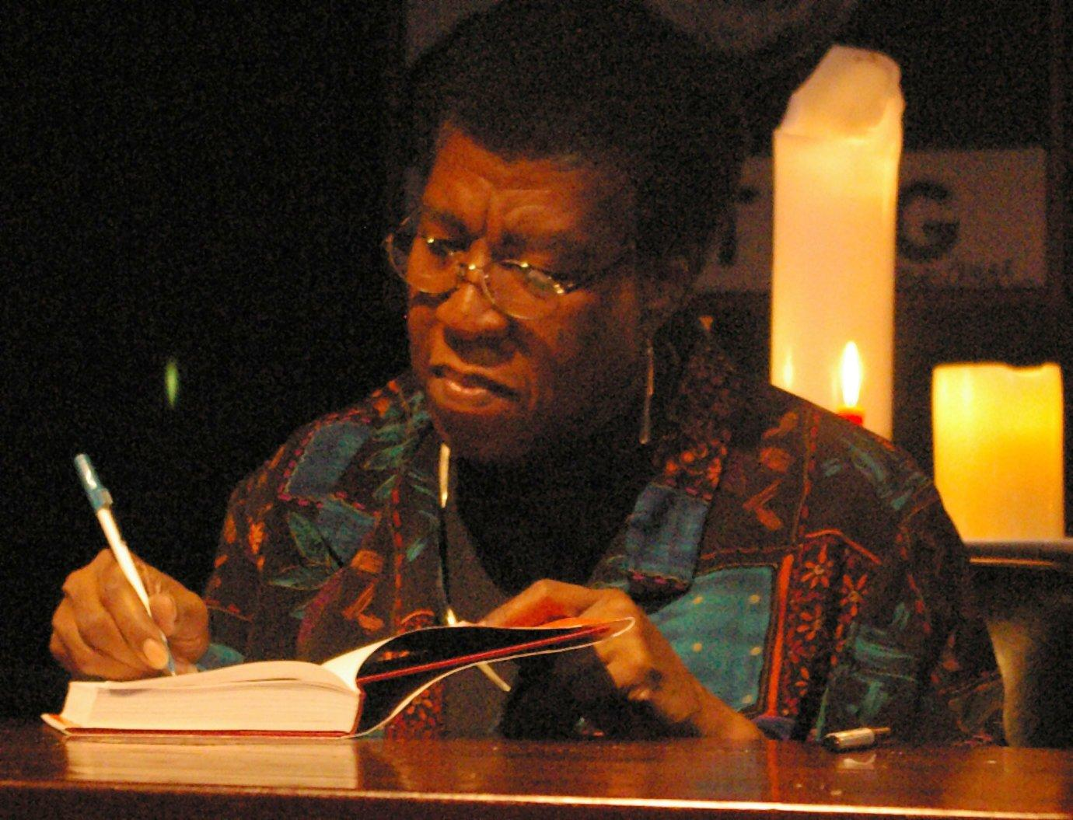  From all the textual clues I was expecting “Old White Man” as author but “Black Granny” was waiting for me. That’s all good, but I’ll admit I was surprised. What did it change for me?  Is Lilith black? The pic on the cover of my book was of two white women, one nude, asleep, and the other uncovering her alien skin/sheets.  So Gramma Butler has read the greats, all the classic tropes are there: distopian future, reluctant messiah, advanced alien technology that demands being dealt with in new ways, morally superior (or not?!) alien species, redefinition of humanity, coupla sexy scenes, and a whole lot of soul searching. I like how she departed from and updated the lasers-and-chrome era SF: organicism. Psyonic beams and telepathic communication are out - chemical communication and direct, physical tentacle-on-tentacle are in. Rather than the sprawling metallic metropolii of an Asimov, the absent Martian ruins of a Bradbury, or the heartless self replicating factories of Dick, we have a living environment, symbiosis at all levels. This was the conceptual gold for me (as a SF fan and STSer?).  I was interested particularly in the choice to capitalize “Awake” throughout the text. “When I was Awoken...”, “I’ve been Awake longer than you.”, “I’m going to Awake 10 more tomorrow,” etc. Perhaps it’s only my personal bias, but between this, the highly meditative, non-hierarchical Oankali, and the vegetarianism, I gave this a mildly Buddhist reading.  Some of problems we moderns face:  How to live with the power of gods (Oankali), and not end up like either Curt or Joseph?  Give a reason or grounding (other than emotion) for “hanging on to your humanity” in the fact of drastic changes brought on by technoscience (aliens). What is that humanity? Isn’t it most clearly shown when Curt kills Joseph?  Is control always a bad thing? Lilith grew steadily more Oankalic over the course of the book, realizing how stupid most people are. Isn’t it the case that sometimes, at least, Doctor knows best? Isn’t the fact that the humans end up repeating Lord of the Flies proof that not all domination is ill-intentioned (Oankali goals were: work together).  Last I’d like to contrast this book with the RIVERWORLD series if anyone is familiar.
Ellen | How much the Oankali manipulate humanity, change their genes, mess with their DNA and genetic make-up has interesting connotations for neo-colonialism as well as what we do with lab animals. For the Lab, there are special caretakers to make sure rats are healthy and stay alive, except for the tumors they may specifically grow on them---manipulating them and deciding when they are ready for changes, ready for sleep, ready for the manipulation. This manipulation runs throughout the novel, but strikes me most at the end when Nikanj decides for Lilith that she is ready to be pregnant and then impregnates her without her consent in the end is the ultimate manipulation. Forcing her to be part of the creation of the Ooankali’s progeny, making her take part even further part --- from Judas scapegoat to Virgin Mary of sorts  "Somehow!" he hissed. "Anyhow! They took stuff from men and women who didn't even know each other and put it together and made babies in women who never knew the mother or the father of their kid-and who maybe never got to know the kid. Or maybe they grew the baby in another kind of animal. They have animals they can adjust to-to incubate human fetuses, as they say. Or maybe they don't even worry about men and women. Maybe they just scrape some skin from one person and make babies out of it- cloning, you know. Or maybe they use one of their prints- and don't ask me what a print is. But if they've got one of you, they can use it to make another you even if you've been dead for a hundred years and they haven't got anything at all left of your body. And that's just the start. They can make people in ways I don't even know how to talk about. Only thing they can't do, it seems, is let us alone. Let us do it our own way."  The beauty of the cancer and the cancerous cells as being a place for learning to the Oankali maps pretty directly on to the life of the HeLa cells and their “strength” for growing. Their great interest to the Oankali reminds me of HeLa’s genes as being of great interest to the researchers. Lilith herself, with her inner strength, may be said to relate to the HeLa cells themselves---her need to survive, adaptability, increased strength, and then the implication that she will reproduce and also has a “print” that will always continue on in memory.  By demanding that the humans help themselves and that Lilith teach them and utilize her slightly manipulated DNA to start from the ground up recalls to me some criticisms of public participation. Mainly the idea that participation implies that there is consensus and that all viewpoints are being heard when policy or decisions are made. Often this does not become the case as there are those with more power in the groups or more “expertise.” So here, by enforcing their DNA on Lilith and taking her on as the Judas scapegoat, she becomes their bridge for human participation. This does not seem to work out too well, in getting all of the humans happy and working together.
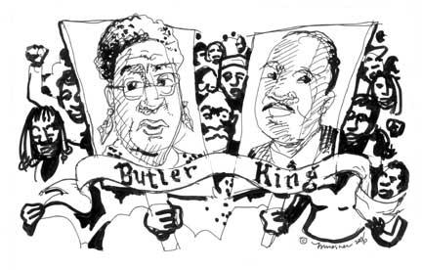
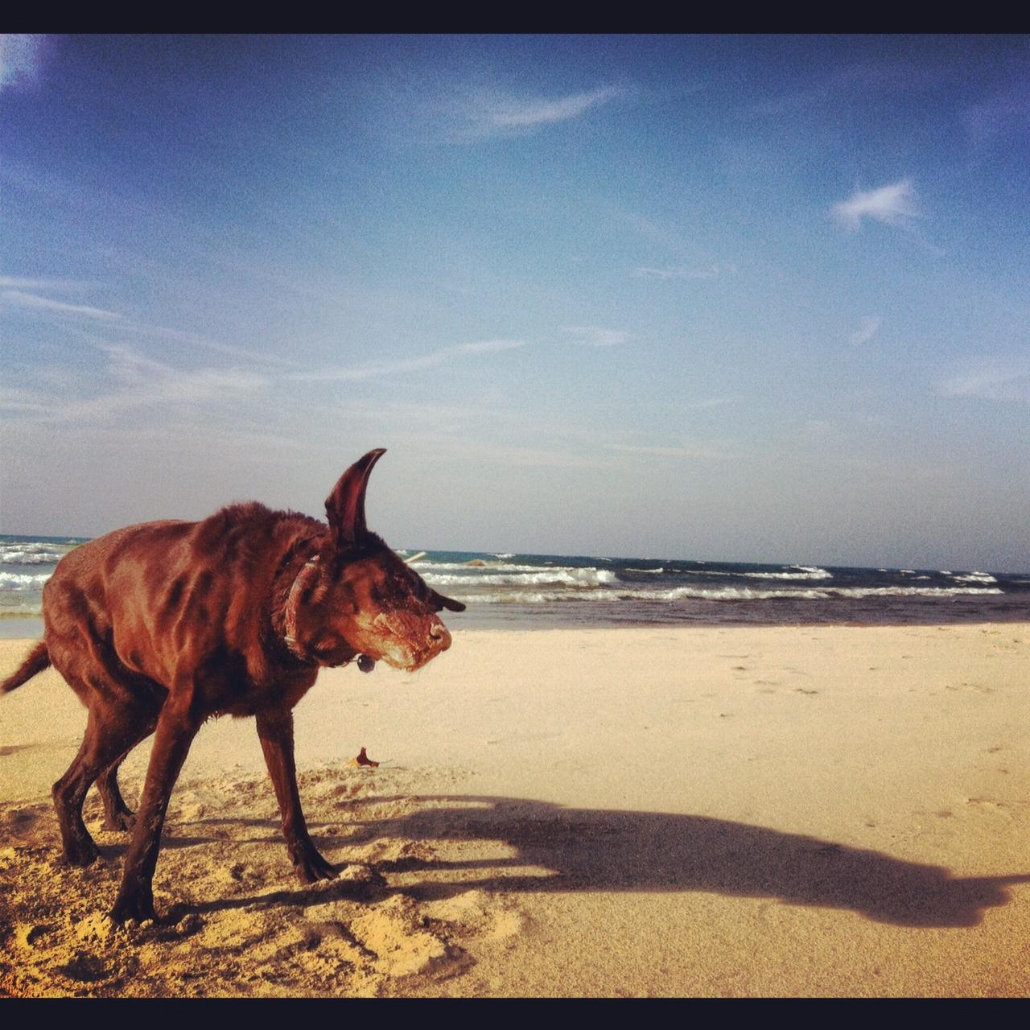http://www.ncbi.nlm.nih.gov/pubmed/10976668
http://www.ncbi.nlm.nih.gov/pubmed/10976668

